PHP 8.5 is installed along with libapache2-mod-php, php-mysql, and supporting packages (php-common, php8.5-cli, php8.5-readline, libargon2-1, etc.)
```bash
sudo nano /var/www/html/info.php
```
Add this content:
```bash
<?php phpinfo(); ?>
```
Saved using (Ctrl+O, Enter, Ctrl+X), then I visited:
```bash
http://23.23.9.29/info.php
```
I used the full PHP configuration page, confirming Apache, PHP, and MySQL integration are all working. That completed my LAMP stack.
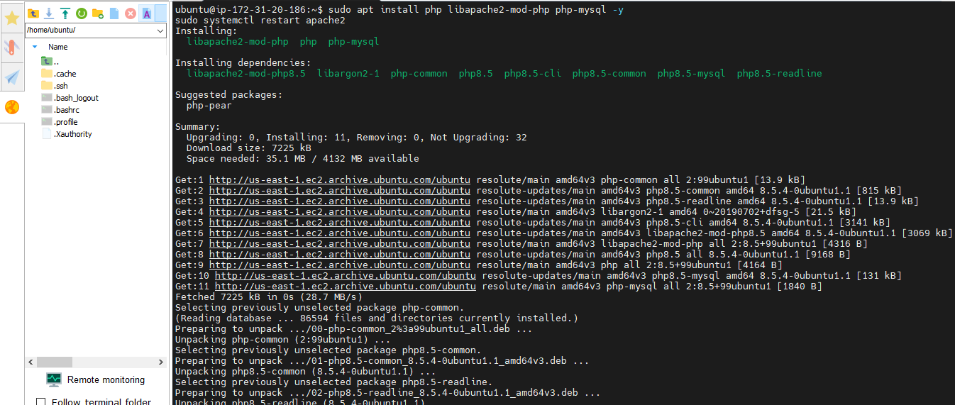

PHP 8.5.4 is installed and working. I confirmed via php -v, with Zend Engine and OPcache loaded.
My LAMP stack is now fully installed: Apache, MySQL, and PHP
I checked to confirm everything's integrated correctly:
```bash
sudo nano /var/www/html/info.php
```
Paste in:
```bash
<?php phpinfo(); ?>
```
Saved using (Ctrl+O, Enter, Ctrl+X), then visited:
```bash
http://23.23.9.29/info.php
```
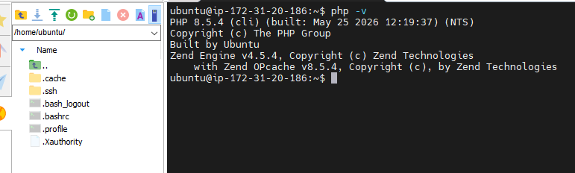

I created a new directory ```bash /var/www/projectlamp ``` while setting up a dedicated project folder instead of using the default /var/www/html. Reason being that I planned to host this as its own virtual host.
Next steps to make this a working site:
1. Set ownership to your user:
```bash
sudo chown -R $USER:$USER /var/www/projectlamp
```
2. Created an index file:
```bash
nano /var/www/projectlamp/index.html
```
3. Set up an Apache virtual host for this directory:
```bash
sudo nano /etc/apache2/sites-available/projectlamp.conf
```
With this content:
```bash
apache
<VirtualHost *:80>
ServerName projectlamp
ServerAlias www.projectlamp
ServerAdmin webmaster@localhost
DocumentRoot /var/www/projectlamp
ErrorLog ${APACHE_LOG_DIR}/error.log
CustomLog ${APACHE_LOG_DIR}/access.log combined
</VirtualHost>
```
4. Enabled the site and disable the default:
```bash
sudo a2ensite projectlamp
sudo a2dissite 000-default
sudo systemctl reload apache2
```

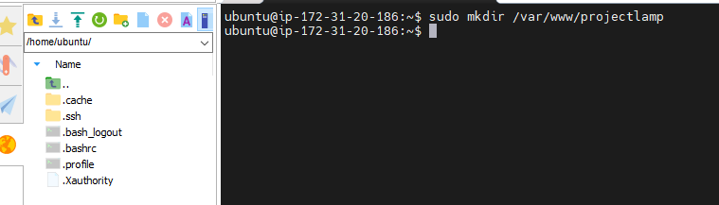

- Virtual host config (projectlamp.conf) was created with the right content
- projectlamp site is enabled, 000-default is disabled
- Apache reloaded successfully
- I created the test file: index.html with "Hello LAMP Project"
I visited my instance's IP in the browser:
```bash
http://23.23.9.29
```
I saw "Hello LAMP Project" displayed instead of the old Apache default page. That confirmed my custom virtual host is live and serving correctly.
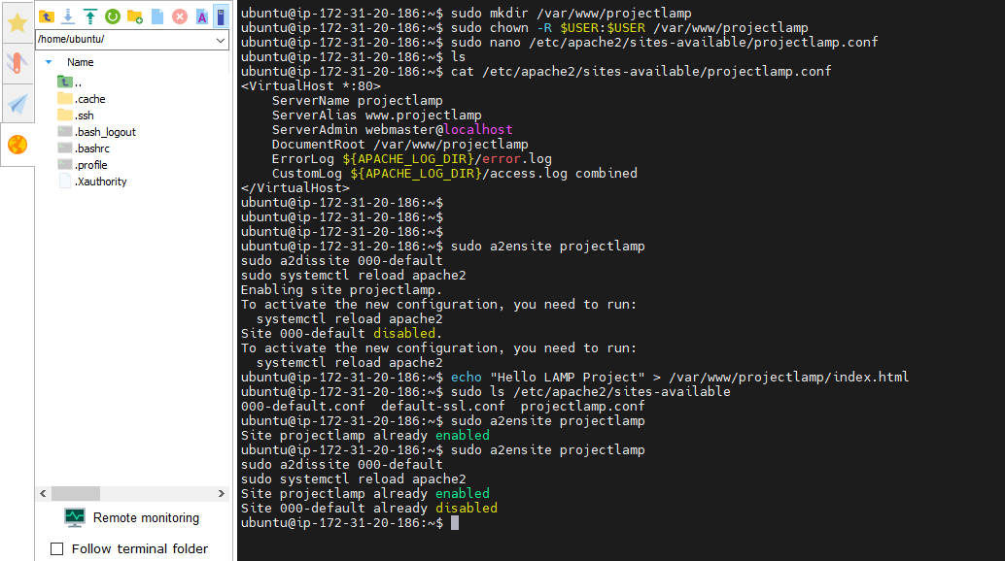
The command ran successfully — both curl calls completed.
Since I chown'd /var/www/projectlamp to my user earlier, the redirect into index.html worked fine without permission errors.
I refresh my browser at:
```bash
http://23.23.9.2
```
I saw: "Hello LAMP from hostname ec2-23-23-9-29.compute-1.amazonaws.com with public IP 23.23.9.29”, confirming that my page is dynamically pulling instance metadata.

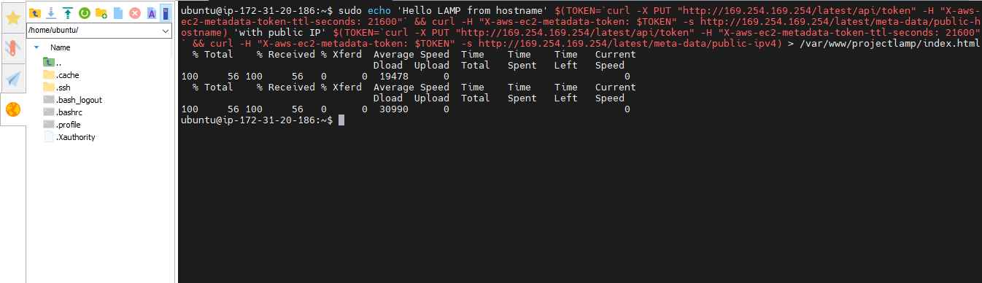

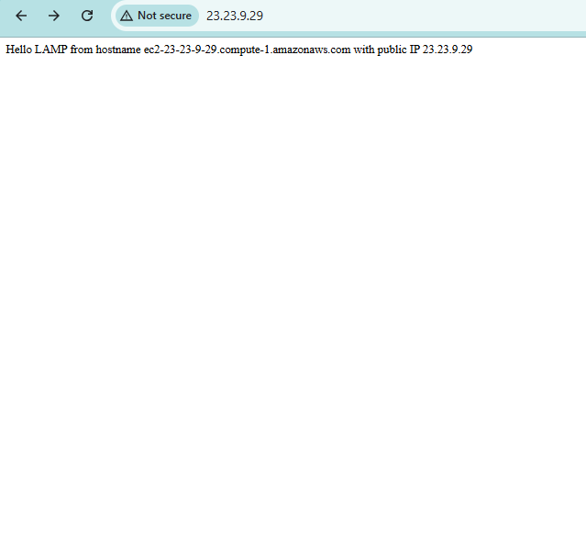The command history shows I:
- Edited dir.conf to prioritize PHP files
- Reloaded Apache (success, no errors)
- Ran vim /var/www/projectlamp/index.php — but without sudo
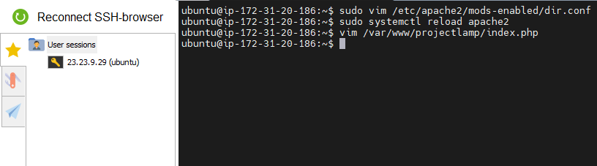

PHP 8.5.4 is properly loaded as an Apache 2 Handler
Configured via /etc/php/8.5/apache2/php.ini
Key extensions loaded: mysqli and pdo_mysql (visible in the "Additional .ini files parsed" list) — meaning PHP can talk to MySQL
64-bit build, Zend Engine active
This confirms my full LAMP stack (Apache + MySQL + PHP) is correctly wired together, with the DB connector extensions in place.
I deleted this test file since phpinfo() exposes server internals:
```bash
sudo rm /var/www/projectlamp/info.php
```
